Unit 3. PRACTICAL WORK.

1 Apache. 2
1.1 Installation 2
1.2 Default configuration 2
1.3 Basic configuration 3
1.4 Directives 3
1.5 Error codes 4
1.6 Modules 4
1.7 Modules installation 5
1.8 Access control 5
1.9 Authentication and authorisation 6
1.9.1 Basic authentication through HTTP 6
1.9.2 Configuration HTTP digest 6
1.9.3 LDAP authentication 7
1.9.4 Log files 8
1.10 Virtual hosts 8
1.11 HTTPS configuration 9
2 Log, monitoring and performance 10
2.1 Log 10
2.2 Monitoring 10
2.3 Performance 10
3 Apache administration with Webmin (optional) 10
3.1 Configuration 11
3.2 Files 11
3.3 Modules 11
3.4 Virtual hosts 11
4 NGINX 11
4.1 Installation 11
4.2 General configuration files 11
4.3 Site configuration 12
4.4 Nginx server blocks 12
4.5 NGINX HTTPS configuration 14
4.6 LOGS in NGINX 15
5 Complete installation of LAMP + Wordpress (optional activity) 16
6 Optional activity. Configure both apache2 and nginx. Make nginx act as a reverse proxy of apache. 16

Changes
Publication date | New sections
8/11/2023
12/11/2023 | Revision of some sections and final translation

You must create a deliverable with a front page where you must include your personal data. For each section,
- you must include a screenshot of the result of following the instructions.
- you must also answer all the questions that are included in this texto.
- you must include the content of the configuration files that are described in these instructions
The name of this document must be Surname_Name_DAW2_DAW_U3.pdf

Apache.

Installation

sudo apt-get install apache2
  - Once installation is finished, the process has included
    - Configuration files
    - User and group www-data. They are the user and the group that will be used by Apache. You can check them in /etc/passwd
    - Folder /var/www/html
      - whose owner is root
      - is the root folder for the default virtual server
  - We can check that server is launched and listening at the 80 TCP port.
ps –ef | grep apache
netstat –ltn
  - Web pages that are located in the folder /var/www/html/ can now be accesible from any web browser (if server is accessible through internet) . Default file is index.html. We can see the default file or overwrite it to have a new one.

Default configuration
- We can see the list of the most important configuration elements in the index.html file that is available after installation.
- We can also list the folder /etc/apache2/
- Let’s check file /etc/apache2/apache2.conf. Does it have links to other files?
- List folder /etc/apache2/sites-enabled. Verify the existence of the 000-default.conf file
- Compare folders /etc/apache2/sites-enabled and /etc/apache2/sites-available. Do they have the same content?
- Let’s check file /etc/apache2/ports.conf. What ports does it include? Which protocols does it refer to?
- Last but not least. Let’s check file /etc/apache2/sites-available/000-default.conf where we can see
  - Directive <VirtualHost>…>/VirtualHost> has the information about the default virtual server.
  - Directive DocumentRoot value
  - Directive ErrorLog value

Basic configuration
- Create an html file whose name is mor.html at /var/www/html
- Create an html named daw.html at /var/www/html
- Create a folder with the name daw2 in /var/www/html llamado daw2. In that folder, create a file whose name is deployment.html

For each of these web pages, we must include a different html code that allows as to distinguish them. It must contain html ,body and h1 tags.

Once this is done, we must try to connect to each of the pages with the url server and the specific route of each of them.
http:// server001.XXXX-XXXX.msierra.cloud/mor.html
http:// server001.XXXX-XXXX.msierra.cloud/daw.html
http:// server001.XXXX-XXXX.msierra.cloud/daw/deployment.html)

Directives

- If there is no index.html file in the root folder of the server, when we try to access the server, what result do we get?

- Let’s change the default file to mor.html (instead of index.html). Access file /etc/apache2/sites-available/000-default.conf and include the directive <Directory> and its content (we can check it in the unit slides)

<Directory /var/www/html>
DirectoryIndex mor.html
Options Indexes FollowSymLinks MultiViews
AllowOverride None
Order allow,deny
allow from all
</Directory>

- We must check that the default page has changed. We must restart server in order to see the changes.

- If we try now to connect to the root of the daw2 folder, we will also see the folder contnt. In order to avoid this behaviour, we are going to include a new directive Directory for the daw2 folder. In this case, as we do not want the content of the folder to be shown neither to have a redirection to any additional page, we will not include the directive DirectoryIndex for the new folder and in Options we will not include the option Indexes.

- Restart the server, check that we can not connect to the specified folder base address / default. Check also that we can still connect to the deployment web page.

Error codes
- We are going to configure the server in order to obtain an error code (404) when a file is not found.
- Edit file 000-default.conf and add a new line with the directive ErrorDocument
ErrorDocument 404 "Web page not fond at DAW2 – IES José MOR"
- Once the server is restarted, every time that we try to access a page that does not exist. we will get the before mentioned error.

- Now we are going to configure the server so we get a web page instead of a text. We must create a file named 404.html in folder /var/www/html/ with a basic content including the message “Web page not found”

- We must modify the same file 000-default.conf. Value for directive ErrorDocument must be

ErrorDocument 404 /404.html

- Once the server is restarted, every time we try to access a page that does not exist, we will be able to see the page we have just created.

Modules

- We can see the list of modules that are loaded by default by executing the following command:

sudo apache2ctl -l

- The list of available modules can be seen in the following folder. For each module, there is a load file .load and a configuration file .conf

/etc/apache2/mods-available

- We can see the list of enabled modules in the following folder. They are links to the mods.available folder

/etc/apache2/mods-enabled

Modules installation

- Lets install module php for apache2 in the server machine. We must execute

sudo apt-get install php
sudo apt-get install libapache2-mod.php

- We must check that the module has been installed correctly. Create a file named index.php in folder /var/www/html/. The content of the file must be <?php phpinfo(); ?>. Try to access it from any web browser.

- Now it’s time to revise folder mods-enabled, is there any difference from the execution you performed previously?

Access control
- In this section we are going to configure access control to some of the pages in our server. Lets create a new folder in /var/www/html called teacher and a file named teacher.html with a basic tontent that will allow us to know which page we are accessing later (e.g. showing text “Teacher’s page”)
- In file /etc/apache2/sites-available/000-default.conf we are going to add a new directive where we ill allow access only from the server, from other machine in the same local network and from our local PC. (check the IPs of each of these machines)
<Directory /var/www/html/teacher>
DirectoryIndex teacher.html
Options Indexes FollowSymLinks MultiViews
AllowOverride None
Order allow,deny
allow from 127.0.0.1
allow from XXX.XXX.XXX.XXX
allow from YYY.YYY.YYY.YYY
</Directory>
- Restart server and try to access the url /teacher from the machines you have specified and also from one that was not in the list. For those machines where you do not have a web browser, you can execute the curl or the wget commands

Authentication and authorisation

In this section we are going to configure a basic authentication system over folder /var/www/html/profesor for allowing access only to users teacher1 and teacher2.
After this first step, we will enable the authentication digest/summary over a new folder named /var/www/html/admin to allow access to users admin1 and admin2

Basic authentication through HTTP

- Verify that module auth-basic is enabled (check previous sections)

- In order to use the baic authentication method, we must create a folder where we will store users and passwords to be added. We must execute the following commands. First time we execute it we add option -c to create file. Once the file has been created, it is not needed any more.

sudo htpasswd –c /etc/apache2/passwd teacher1
sudo htpasswd /etc/apache2/passwd teacher2

- We are going to modify file /etc/apache2/sites-available/000-default.conf and add in the directive /var/www/html/teacher the following lines:
<Directory /var/www/html/teacher>
DirectoryIndex teacher.html
Options Indexes FollowSymLinks MultiViews
AllowOverride None
Order allow,deny
allow from 127.0.0.1
allow from XXX.XXX.XXX.XXX
allow from YYY.YYY.YYY.YYY
AuthType Basic
AuthName "Restricted access"
AuthUserFile /etc/apache2/passwd
Require user teacher1 teacher2
</Directory>
- Restart server and try to connect to the teacher web page. Verify that the server is requesting the credentials we have just configured.

Configuration HTTP digest

- Let’s create a folder named /var/www/html/admin . In this same folder we create file admin.html with some information that allows its later identification (e.g. “I am the web page of the DAW2 admin”
- Now let’s enable module auth_digest with the following command
sudo a2enmod auth_digest
- Restart server
- We are going to create a file where users and passwords will be stored. Realm field (in our example “superusers” is used to make groups and grant them access.
sudo htdigest –c /etc/apache2/digest superusers admin1
sudo htdigest /etc/apache2/digest superusers admin2
- Now we are going to access file /etc/apache2/sites-available/000-default.conf y and we will add directive /var/www/html/admin the following information

<Directory /var/www/html/admin>
DirectoryIndex admin.html
Options Indexes FollowSymLinks MultiViews
AllowOverride None
Order allow,deny
allow from all
AuthType Digest
AuthName "superusers"
AuthDigestProvider file
AuthUserFile "/etc/apache2/digest"
Require user admin1 admin2
</Directory>
- Restart server and try to connect to url /admin with the credentials we have just created.

LDAP authentication
- Create a folder named /var/www/html/students and, in the same folder, create file student.html with a specific message like “Hi, I am the student page, be careful with me” that allows to distinguish it later.
- Let’s enable the modules that are needed for LDAP authentication.
  - a2enmod ldap
  - a2enmod authnz_ldap
- Now we must modify file /etc/apache2/sites-available/000-default.conf and add directive /var/www/html/students with the following info

<Directory /var/www/html/students>
DirectoryIndex student.html
Options Indexes FollowSymLinks MultiViews
AllowOverride None
Order allow,deny
allow from all
AuthName "Students area"
AuthBasicProvider ldap
AuthType Basic
AuthLDAPBindAuthoritative Off
AuthLDAPURL "ldap://127.0.0.1:389/dc=dawlocal,dc=net"
Require valid-user
</Directory>

Check the AuthLDAPURL in order to include the information for your LDAP server.

- Try to connect to the /students web page. You will be requested to introduce a user and a password. You must include uid and password. Try to access url http://server xxxx.xxx/students/. You will be requested to introduce a username and a password. You must include uid and password for any student created in your LDAP folder. If information is correct, you will be able to see the student.html page that you have just created.

Log files
- Path to the log files folder is in file 000-default.conf
- These files are: /var/log/apache2/error.log and /var/log/apache2/access.log ((have a look at them and include a screenshot)

Virtual hosts
Next step is the creation of two virtual hosts: daw1.serverXXXX.XXX and daw2.server XXX.XXX.
- Configure DNS server so both urls point to the same server address.

We can do it by adding a two new entries in the DNS server. In order to minimize the number of changes to do every time that the public address changes, we are going to create two new CNAME records with the following format. Remember to change the entries with the name of your specific subdomain.

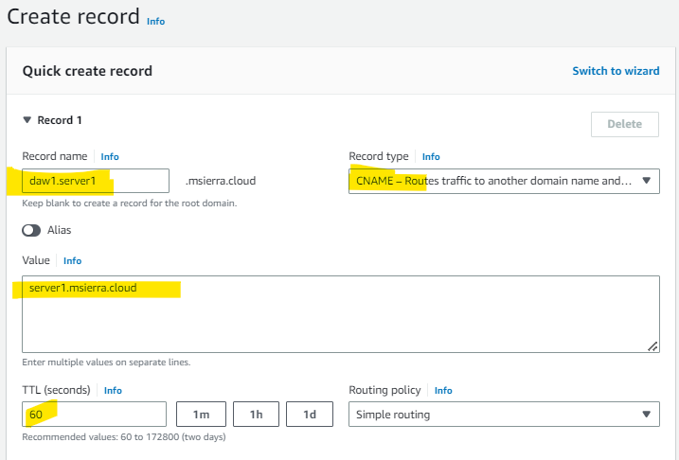

- Once we have verified that DNS server resolves correctly both names, we a regoing to configure apache to work with the two virtual hosts.


- First step is to disable default virtual hosts.

sudo a2dissite 000-default.conf
After its execution, remember that we must restart the server
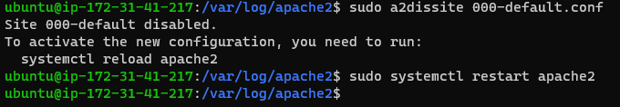
- After this step, we can check that folder /etc/apache2/sites-enabled is empty and folder /etc/apache2/sites-available has not been modified yet.
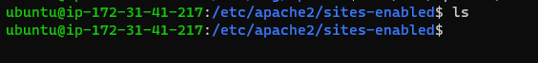

- Now we are going to create the new two new virtual hosts.
  - Check that folder /var/www/html/daw1 exists and that it has a file named index.hmtl.
  - Create folder /var/www/html/daw2 and, in that folder, create a file named index.html with content that allows us to identify that site/file (e.g. a message showing DAW2 or something similar)
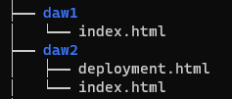

- Create and configure files /etc/apache2/sites-available/daw1.conf and /etc/apache2/sites-available/daw2.conf. In order to do that, copy file 000-default.conf and change the following directives (information for daw1 is shown, daw2 would be the same)

ServerName daw1.serverxxx.xxx
Directory
<Directory /var/www/html/daw1>
DirectoryIndex index.html
Options FollowSymLinks MultiViews
AllowOverride None
Order allow,deny
allow from all
</Directory>
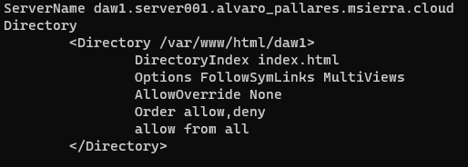

- Enable both virtual sites by running
sudo a2ensite daw1.conf
sudo a2ensite daw2.conf

- Now you must check that links to the files in folder sites-enabled have been created

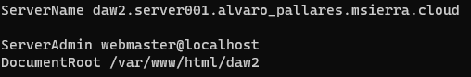
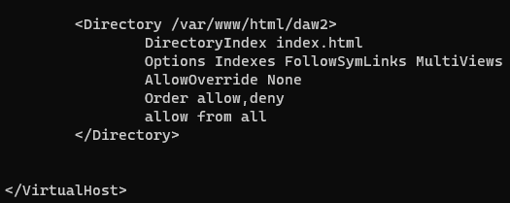

- Finally, we can check that we have access to the new hosts from the web browser of any machine.

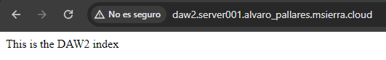

HTTPS configuration
- Remember restart the server every time you make a change and want to verify the new functionality.
- We are going to enable again the default virtual host. Before that, we are going to disable the new virtual hosts that have just been created (daw1 and daw2)
sudo a2dissite daw1.conf
sudo a2ensite daw2.conf
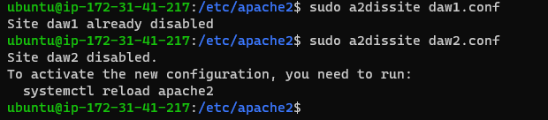
- Let’s activate the default virtual host
sudo a2ensite 000-default.conf
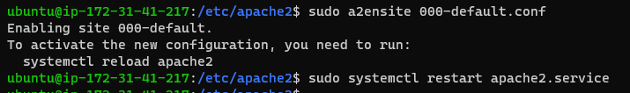
- Activation of the ssl module
sudo a2enmod ssl
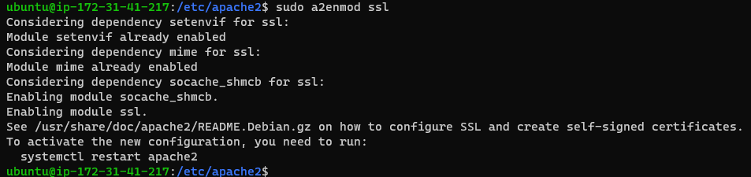

- Revise file /etc/apache2/ports.conf to check that server will use port 443 for SSL requests.
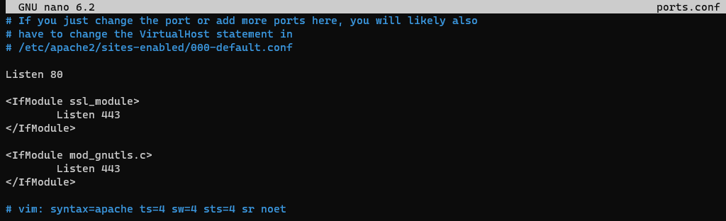
- Verify that server is listening at ports 80/TCP and 443/TCP by executing the command
netstat -ltn
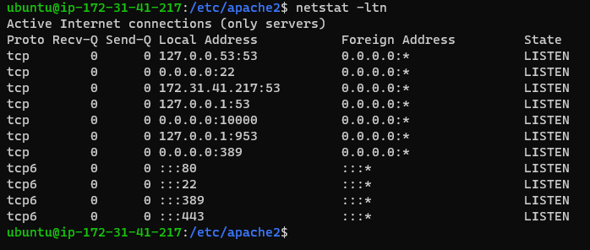
- Enable default ssl site
sudo a2en2ensite default-ssl.conf
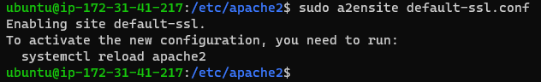
- Follow the instructions included in the slides of this unit.

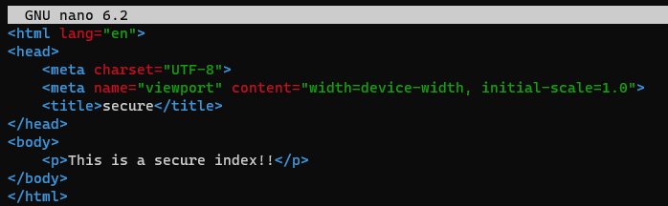
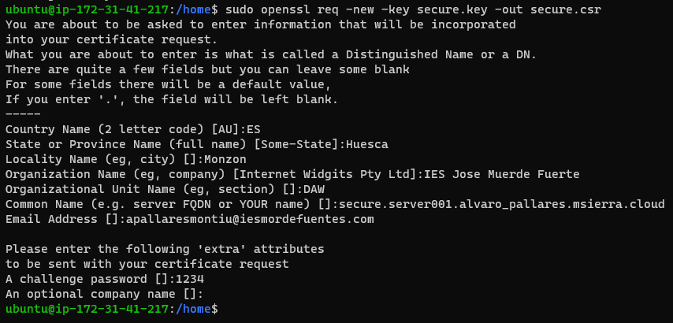
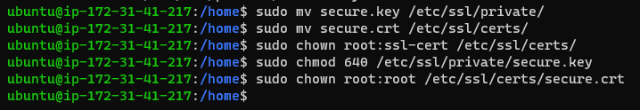
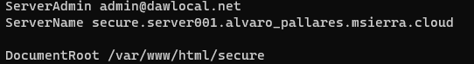

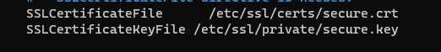

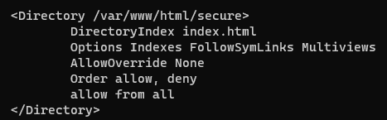

- If we have a look at file /etc/apache2/sites-available/default-ssl.conf we can see that apache is going to use a self-signed certificate (web browsers will inform about this circumstance)
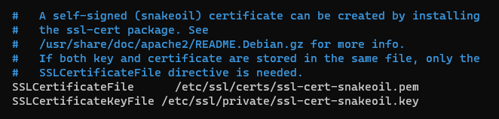
- If we try to access site with https, we will be informed about the certificate being self-signed, but we will be able to access site.
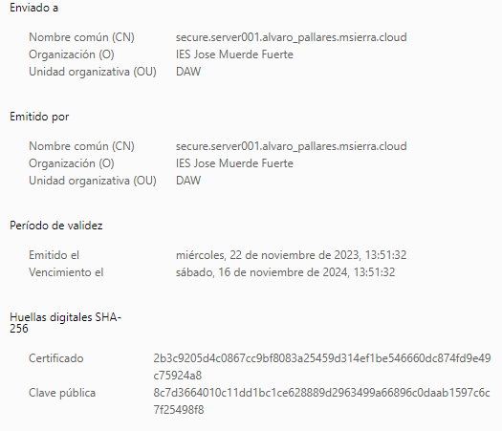


Log, monitoring and performance

Log
In apache there are two main types of records, access and error.
- Options by default are included in file apache2.conf (you must include some screenshots of the configuration option(s) at the file).


- Besides file apache2.conf, where can we find other routes to log files?
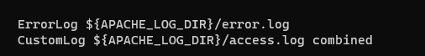

At 000-default.conf file
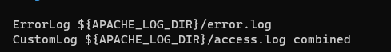

- Include a screenshot of some files of file access.log and explain the values for the fields of one of the records.
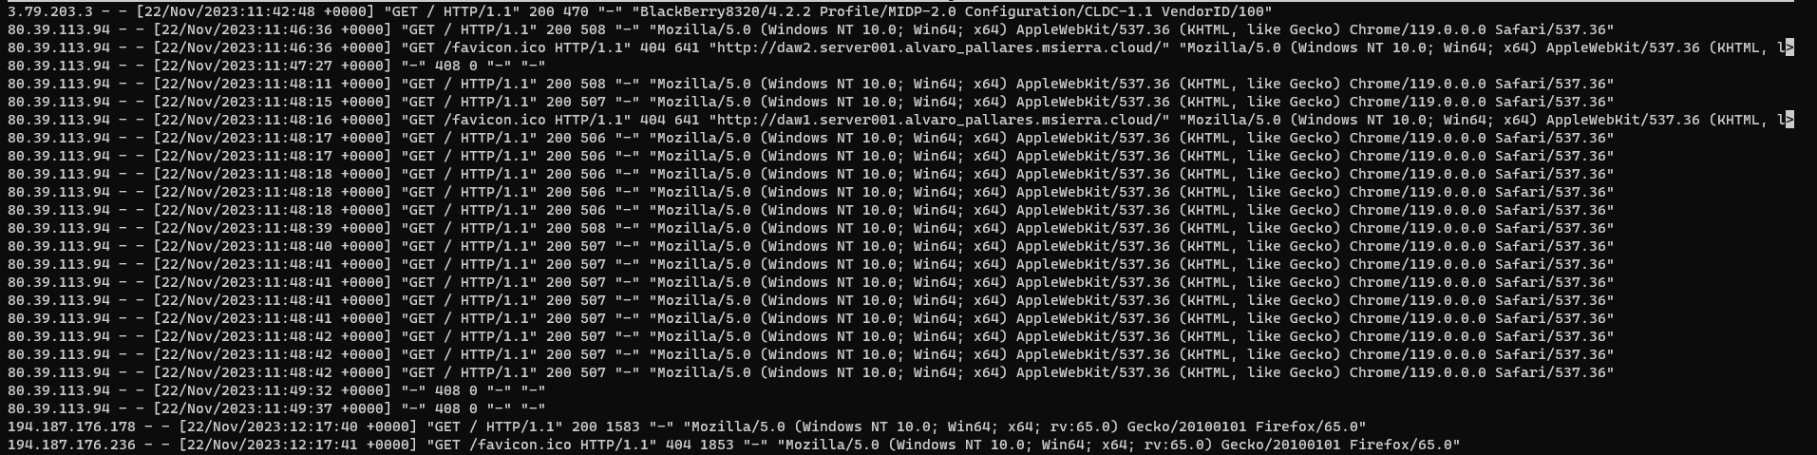
First we got the IP, the date, method (GET OR POST i dont see anything else), the protocol that i use to connect, the domain i visit
- Additional tasks:
  - Change configuration of logs for DAW1 site
  - Logs configuration is at /etc/logrotate.d
  - Log levels can be configured with LogLevel
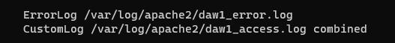

Monitoring3
- Access URL http://serverXXX.XXX/server-status and include a screenshot of the information that is shown. Make a request from other machine and reload the server-status page. Include another screenshot. Has there been any change?
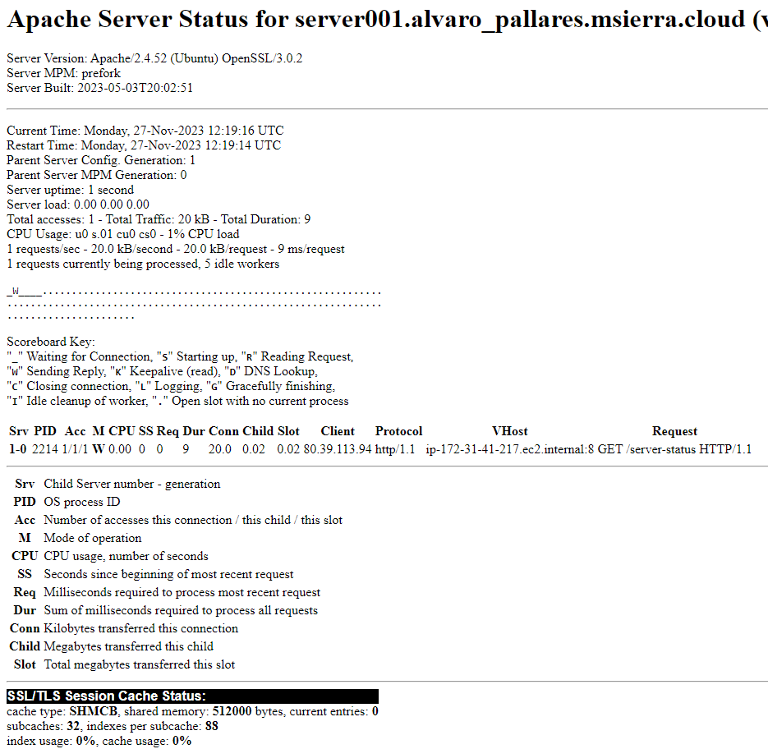
- Info module shows information about the module configuration.

sudo a2enmod info
http://serverXXX.XXXX/server-info/

- Module is installed but not enabled by default. Enable module and access url http://serverXXX-XXX/server-status. You must include a screenshot of the output. Check configuration of module mod_log_config.c and provide an explanation of the relation between one of the entries in the log_format with a line of the record file from the previous section.
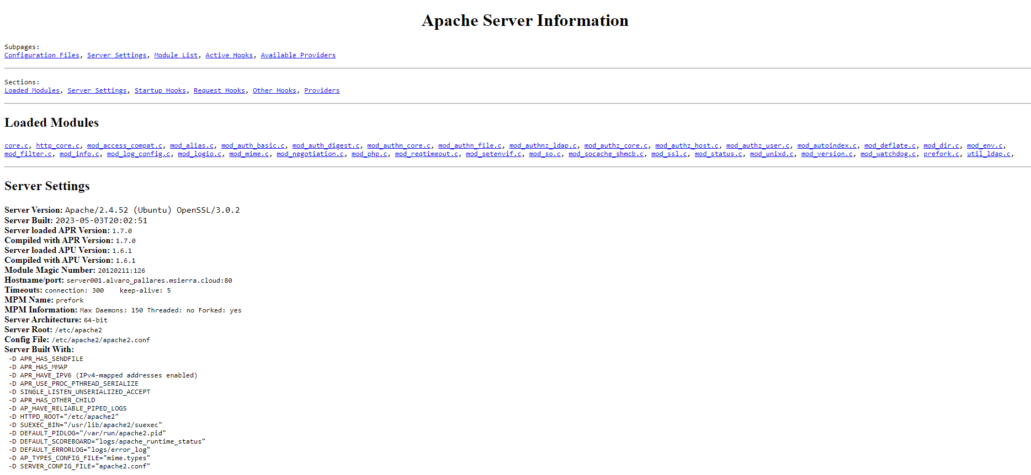

Performance
Ab tools helps to measure the performance of the webserver. We can provide parameters for the number of requests and also for the name of users. Make a request to server for 1500 requests and 25 users.

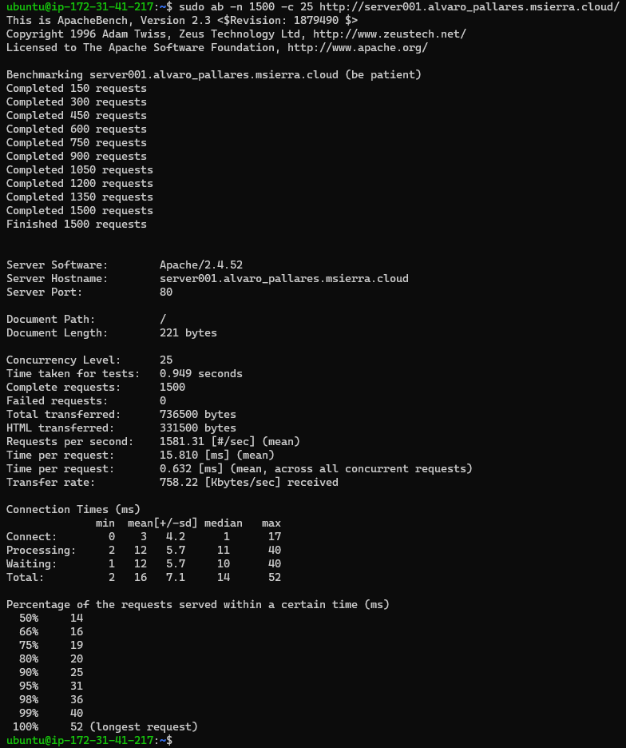
Apache administration with Webmin (optional)
More information in page
https://doxfer.webmin.com/Webmin/Apache_Webserver

Configuration
- To configure Apache from Webmin, go to the "Unused Modules" group and select "Apache Webserver."
- You can verify that you are accessing the same server that you have configured through the command line, and that the same parameters are displayed
- If you click on the "Refresh Modules" option, you will see the Apache module appear in the list of servers.

Files
- To view the files on our server, we can go to the "Others" menu and select "File Manager." We will be able to see the files we have created, create new ones, edit them, and delete them. In the directory /var/www/html, we have the information that we have been generating.
- We can create a new file and verify that it is accessible from the browser.

Modules
- We can see the modules that are configured in the "Modules" section, as well as enable or disable them.

Virtual hosts
- The virtual hosts that we have created previously are accessible from the "Existing virtual hosts" tab. We can review their configuration to check where the directives applied through the corresponding files appear and how they can be activated and deactivated from the Webmin menus.

NGINX
Information at http://nginx.org/ and at https://ubuntu.com/tutorials/install-and-configure-nginx#1-overview

Installation
- Before we start, we must stop Apache server.
- Nginx installation. Let’s use Nginx packet.
  - sudo apt-get install nginx
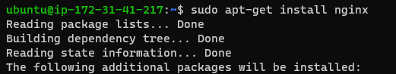

- Once installed, we can verify it is working by executing the command
  - ps –ef | grep nginx
  - service nginx status
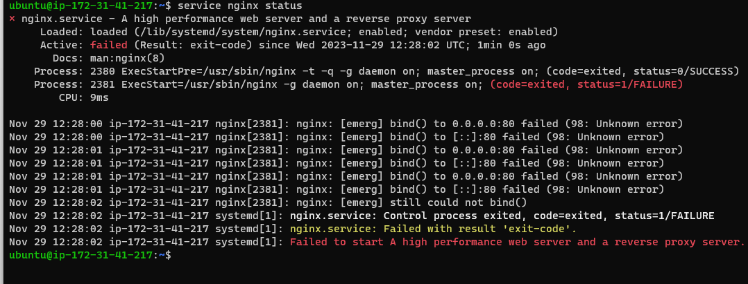
- Default page is placed in /var/www/html/location. Same as for apache2. Verify that the default page is accessible. And also check that you are able to access the default index for NGINX located at /var/www/html/index.nginx-debian.html.
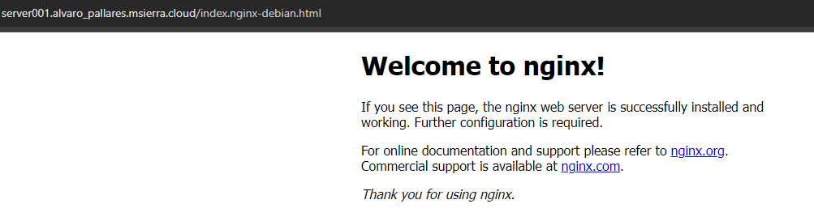

General configuration files
- Configuration files are located at: /etc/nginx (include a screenshot of the files that are located in the folder)
- nginx.conf is the main configuration file. There are three simple directives and three high level ones.
  - Simple directives are:
user www-data
worker_processes auto;
pid /run/nginx.pid;
    - user: Specifies the user and group credentials used by nginx processes. If the group is omitted, a group with a name matching the user's will be used.
    - worker_processes: Defines the number of processes. The optimal value depends on various factors such as the number of CPU cores, the number of hard drives storing information, and the load pattern. If any of these values are unknown, you can try using the number of available CPU cores (the "auto" value will attempt to autodetect it).
    - pid: Specifies the file that will store the process identifier of the main process.
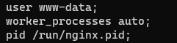

  - High level directives are (there are also some included in them):
    - events: Provides the configuration context in the file where directives affecting connection processing are specified.
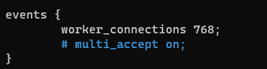

    - http: Provides the configuration context in the file where HTTP directives for the server are specified.
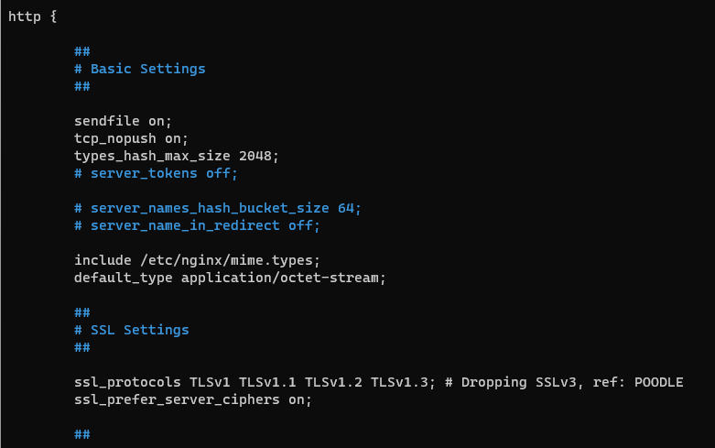
    - mail (commented): Provides the configuration context in the file where mail directives for the server are specified. (Note: The mention of "commented" suggests that this section may be commented out or not active in the configuration.)
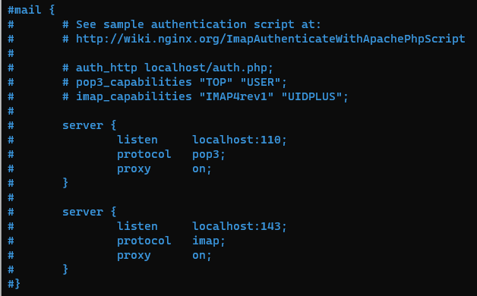

Site configuration
- Folders /etc/nginx/sites-available and /etc/nginx/sites-enabled have a funcionality similar to the one in Apache.
- default file contains all the information of the virtual host
- Let’s edit file /etc/nginx/sites-available/default. We are going to put the index.html of NGINX as the first option when we connect to the default web page of the server.

- 
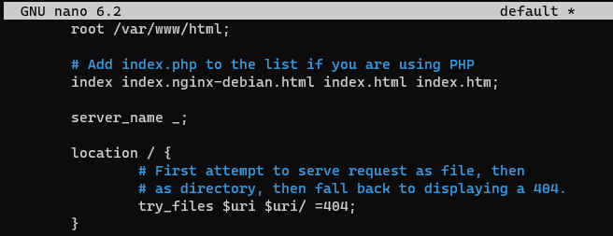
- Once we restart the server, we can see that the index file has changed

Nginx server blocks
Nginx Server Blocks allow the configuration of more than a website in a single server independently. For each site, we can configure a root, a security policy, an ssl certificate,… The concept is similar to the virtual hosts concept in Apache.
- We create the corresponding entry in the DNS service for nginxsite.serverXXXX.XXXX
- We create a folder structure in /var/www for the new site (nginx/nginxsite)
- We create an index.html file in the folder we have just created.
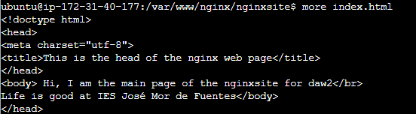

- We create a server block by creating a file in the sites-available folder.
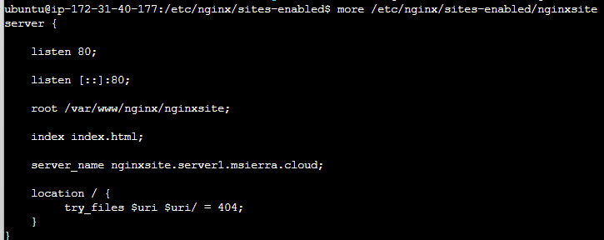
- We enable the file by creating a link from folder sites-enabled. Habilitamos el archivo creando un enlace desde el directorio sites-enabled

- In file nginx.conf we must uncomment the specified directive in order to avoid a potential problem of hash bucket memory

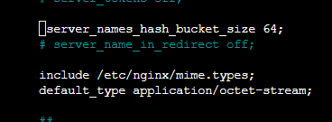

- Check that there are no errors

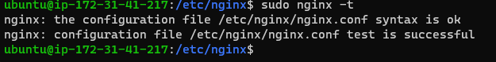
- Restart nginx and try to access again the web page

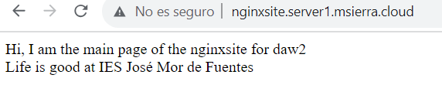

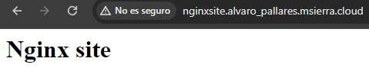

NGINX HTTPS configuration
- We are going to configure the Nginx server to accept HTTPS
- We will use the secure.crt certificate created in the theory session (if not created, follow the steps in the slides, and make sure we have the files secure.key in the /etc/ssl/private directory and secure.crt in /etc/ssl/certs/ directory).
- Also, make sure that the DNS entry secure.serverXXXX.XXX is created on the DNS server.
- Follow the steps to create the server block for the secure server in the same way as in the previous section for the site nginx. In this case, we should be able to connect to it in an insecure manner.
- Modify the configuration file for the secure server with the following content:

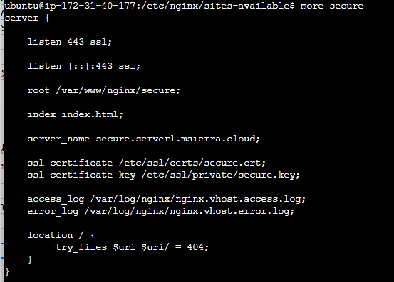

- Restart the server. Access the server through both HTTP and HTTPS. What happens?
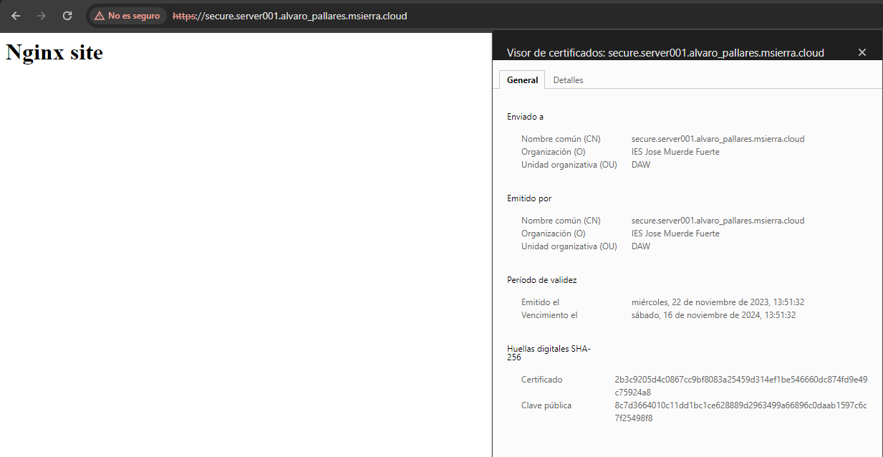

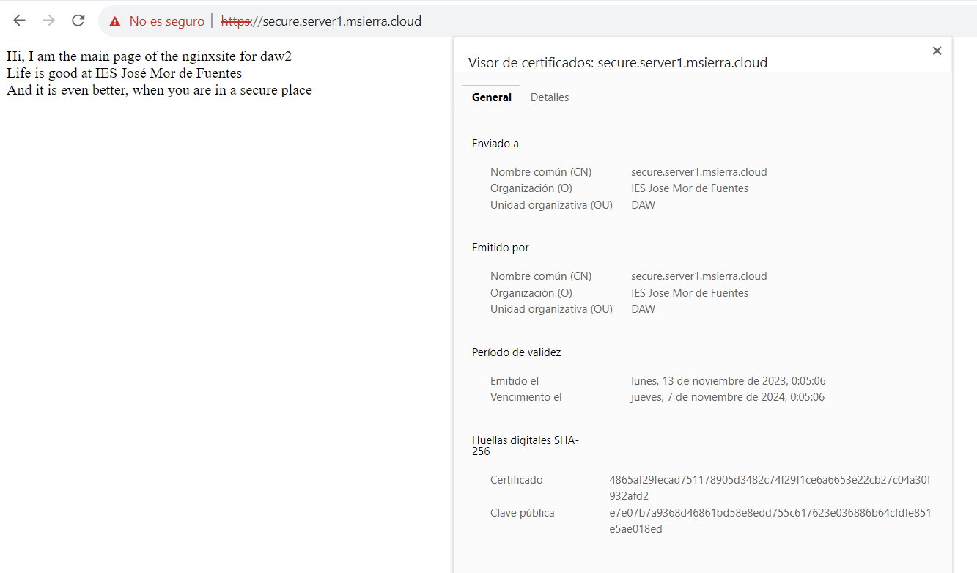
- Add the necessary configuration to the file to redirect HTTP traffic to HTTPS. Add the directive to the configuration file.

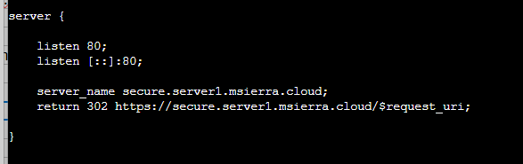

- Restart the server. Access the server again through both HTTP and HTTPS. What happens?
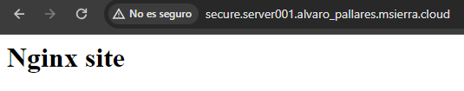
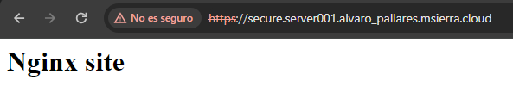

LOGS in NGINX
- Review the location of log files in the configuration files of the site. Where are they configured? What are the file names?
They are configured at /etc/nginx/sites-avaible/default file.
Their names are nginx.vhost.acces.log and nginx.vhost.error.log
- Include a screenshot of the log files. Is the format similar to that of Apache?
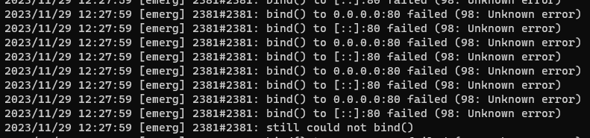
Yes, the format is very similar.

Complete installation of LAMP + Wordpress (optional activity)

- To complete the deployment of a web application, besides the web server, it is usually necessary to install additional elements.
- Follow the tutorials to install the components of LAMP according to the following links:
  - https://www.digitalocean.com/community/tutorials/how-to-install-linux-apache-mysql-php-lamp-stack-on-ubuntu-20-04-es
  - https://www.digitalocean.com/community/tutorials/how-to-install-and-secure-phpmyadmin-on-ubuntu-20-04
  - https://www.digitalocean.com/community/tutorials/how-to-install-wordpress-on-ubuntu-20-04-with-a-lamp-stack-es

- NOTE: Those components that were previously installed, do not need to be installed again

Optional activity. Configure both apache2 and nginx. Make nginx act as a reverse proxy of apache.

